OS LAB 3
22k-5195 Laiba Fatima
IN LAB:
1:
#!/bin/bash
# Log File Analyzer # Accept log file as input log_file="$1"
# Count total number of requests total_requests=$(wc -l < "$log_file") # Determine number of unique IP addresses
unique_ips=$(awk '{print $1}' "$log_file" | sort -u | wc -l)
# Identify top 5 most frequent IP addresses
top_ips=$(awk '{print $1}' "$log_file" | sort | uniq -c | sort -nr | head -5)
# Calculate total size of data transferred
total_size=$(awk '{sum += $10} END {print sum}' "$log_file")
# Generate summary report
echo "Log File Analysis Report" > analysis_report.txt echo "-------------------------" >> analysis_report.txt echo "Total Requests: $total_requests" >> analysis_report.txt echo "Unique IP Addresses: $unique_ips" >> analysis_report.txt echo "Top 5 IP Addresses:" >> analysis_report.txt echo "$top_ips" >> analysis_report.txt
echo "Total Size of Data Transferred: $total_size bytes" >> analysis_report.txt echo "Report generated on: $(date)" >> analysis_report.txt

OR
#!/bin/bash

# Check if the input log file is provided
if [ -z "$1" ]; then
echo "Usage: $0 <log_file>"
exit 1
fi

# Assign the input log file to a variable
logfile="$1"

# Count the total number of requests
total_requests=$(wc -l < "$logfile")

# Determine the number of unique IP addresses
unique_ips=$(awk '{print $1}' "$logfile" | sort | uniq | wc -l)

# Identify the top 5 most frequent IP addresses and their corresponding request counts
top_ips=$(awk '{print $1}' "$logfile" | sort | uniq -c | sort -rn | head -n 5)

# Calculate the total size of data transferred
total_size=$(awk '{sum+=$NF} END {print sum}' "$logfile")

# Generate a summary report
summary_report="Total requests: $total_requests\n"
summary_report+="Unique IP addresses: $unique_ips\n"
summary_report+="Top 5 most frequent IP addresses:\n$top_ips\n"
summary_report+="Total data transferred (in bytes): $total_size\n"

# Save the summary report to an output file
output_file="log_summary_report.txt"
echo -e "$summary_report" > "$output_file"

echo "Summary report generated: $output_file"

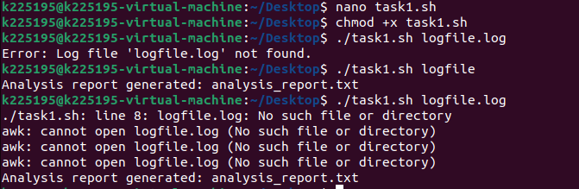
POST LAB:
1:
#!/bin/bash

directory_path="$1"
new_file_name_pattern="$2"

if [ ! -d "$directory_path" ]; then
echo "Error: Directory not found."
exit 1
fi

if [ -z "$(ls -A "$directory_path")" ]; then
echo "Error: Directory is empty."
exit 1
fi

if [ -z "$new_file_name_pattern" ]; then
echo "Error: Please provide a new file name pattern."
exit 1
fi

counter=1

for file in "$directory_path"/*; do
if [ -f "$file" ]; then
file_extension="${file##*.}"
new_file_name="${new_file_name_pattern}${counter}.${file_extension}"
mv "$file" "$directory_path/$new_file_name"
if [ $? -eq 0 ]; then
echo "Renamed '$file' to '$new_file_name'"
else
echo "Error: Failed to rename '$file'."
fi
((counter++))
fi
done
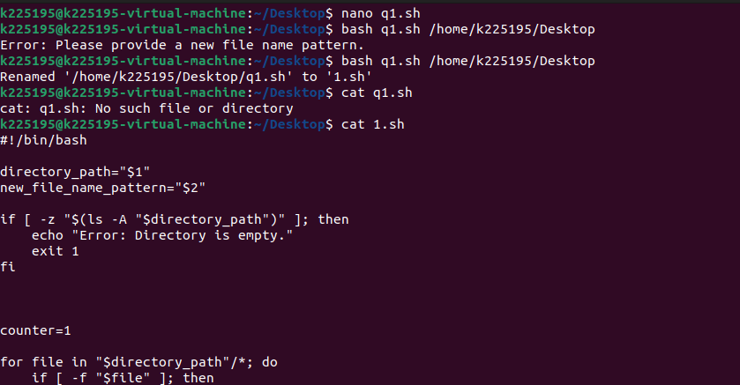
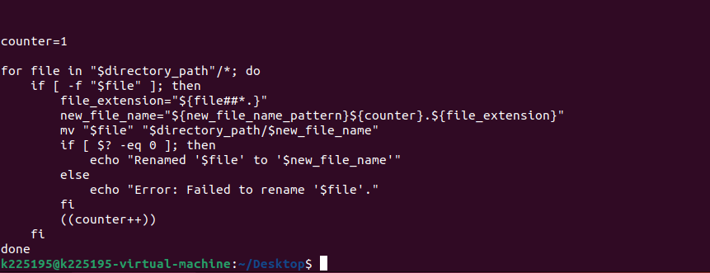
2:
#!/bin/bash

# Function to remove old files
remove_old_files() {
local directory="$1"
local days="$2"
local count=0
while IFS= read -r -d '' file; do
if [[ -f "$file" ]]; then
if [[ $(($(date +%s) - $(stat -c %Y "$file"))) -gt $((days * 86400)) ]]; then
rm "$file"
((count++))
fi
fi
done < <(find "$directory" -type f -print0)
echo "Removed $count files older than $days days."
}

# Function to remove empty directories recursively
remove_empty_directories() {
local directory="$1"
local count=0
while IFS= read -r -d '' dir; do
if [[ -d "$dir" && -z "$(ls -A "$dir")" ]]; then
rmdir "$dir"
((count++))
fi
done < <(find "$directory" -type d -print0)
echo "Removed $count empty directories."
}

# Main script
if [[ $# -ne 1 ]]; then
echo "Usage: $0 <directory>"
exit 1
fi

directory="$1"

if [[ ! -d "$directory" ]]; then
echo "Error: $directory is not a valid directory."
exit 1
fi

read -p "Enter the number of days to consider as old for files: " days

if [[ ! $days =~ ^[0-9]+$ ]]; then
echo "Error: Invalid input for days."
exit 1
fi

remove_old_files "$directory" "$days"
remove_empty_directories "$directory"

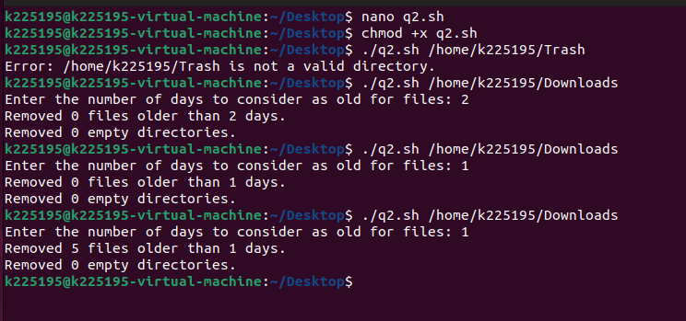
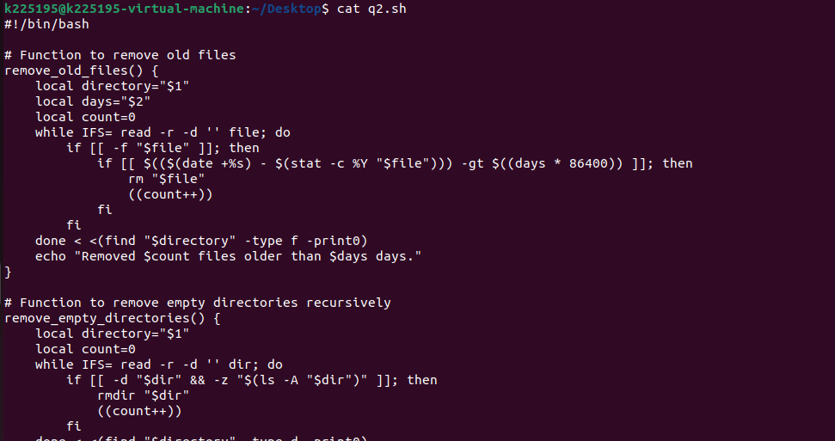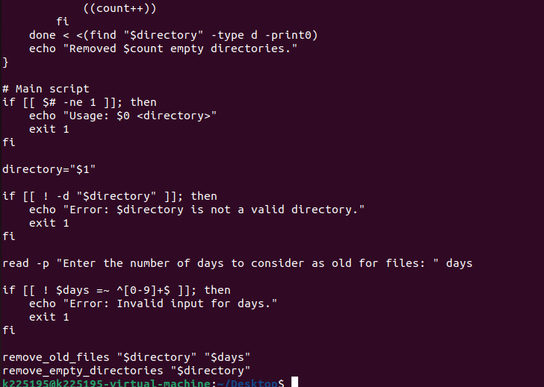

3:
#!/bin/bash

# Function to collect CPU usage
get_cpu_usage() {
cpu_usage=$(top -bn1 | grep "Cpu(s)" | sed "s/.*, *\([0-9.]*\)%* id.*/\1/" | awk '{print 100 - $1}')
echo "CPU Usage: $cpu_usage%"
}

# Function to collect memory usage
get_memory_usage() {
memory_usage=$(free | grep Mem | awk '{printf "%.2f", $3/$2 * 100}')
echo "Memory Usage: $memory_usage%"
}

# Function to collect disk space
get_disk_space() {
disk_space=$(df -h | awk '$NF=="/"{printf "Disk Usage: %s", $5}')
echo "$disk_space"
}

# Function to collect network traffic
get_network_traffic() {
network_traffic=$(ifstat 1 1 | awk 'NR==3{print "Incoming: " $6 " | Outgoing: " $8}')
echo "$network_traffic"
}

# Function to calculate average values
calculate_average() {
duration=$1
# Calculate average CPU usage
avg_cpu=$(top -bn$duration -d1 | grep "Cpu(s)" | tail -n$duration | awk '{total += (100 - $8)} END {print total/NR}')

# Calculate average memory usage
avg_memory=$(free -m | awk 'NR==2{total += $3} END {print total/NR}')

echo "Average CPU Usage (over $duration seconds): $avg_cpu%"
echo "Average Memory Usage (over $duration seconds): $avg_memory MB"
}

# Function to generate report
generate_report() {
report_file="system_report_$(date +'%Y-%m-%d_%H-%M-%S').txt"
echo "System Report" > "$report_file"
echo "------------------------" >> "$report_file"
get_cpu_usage >> "$report_file"
get_memory_usage >> "$report_file"
get_disk_space >> "$report_file"
get_network_traffic >> "$report_file"
calculate_average "$1" >> "$report_file"
echo "Report generated: $report_file"
}

# Main script
echo "System Monitoring Script"
echo "------------------------"
echo "1. Generate report"
echo "2. Exit"

read -p "Enter your choice: " choice

case $choice in
1)
read -p "Enter duration for average calculation (in seconds): " duration
generate_report "$duration"
;;
2)
echo "Exiting script."
exit 0
;;
*)
echo "Invalid choice. Exiting."
exit 1
;;
esac
